Question 3: (2.0 Point)
Design the form which at running might look something like figure below (the white area is a JList object): (0.5 Point)
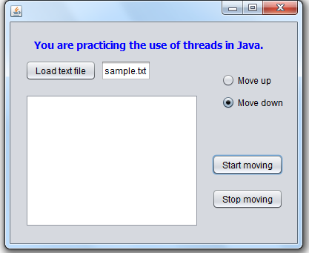
When you click the button Load text file, the content of the file sample.txt is loaded in to the JList, each line in the file will be one item in the list.

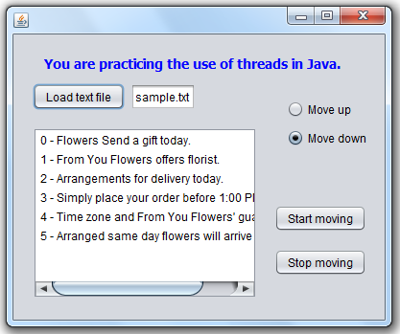
If no radio button is selected, then the alert window appears to promp the user to select a radio button.
If a user click Start moving button then
If the Move up radio button is selected then lines in the list move up.
Otherwise lines in the list move down (in every 0.5 seconds).

